**Deadlines**

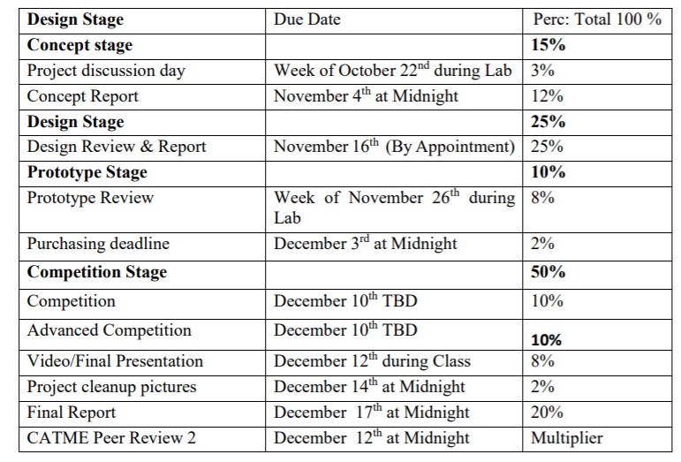

**Plan**

|  |  |  |  |
| --- | --- | --- | --- |
| **Week** | **Goals** | **Meeting Dates** | **Description of Task** |
| **Nov 5-Nov 11** | **Design (Part 2)** | **5(5:30…),6(5PM-7PM),7(5PM-7PM),8(3PM-5PM),9(3PM-7PM),10( ),11( )** | **CAD,PVA,Budgeting** |
| **Nov 12-Nov-18** |  |  |  |
| **Nov 19-Nov 25** |  |  |  |
| **Nov 26-Dec 3** |  |  |  |
| **Dec 3- Dec 10** |  |  |  |

<http://www.mekanizmalar.com/mechanical-spider.html?utm_source=rb-community&utm_medium=forum&utm_campaign=how-to-get-dimensions-for-klann-linkage-from-mechanicalspider-com>

<https://www.diywalkers.com/klanns-linkage-plans.html>

Lnk Lengths Computations

<http://demonstrations.wolfram.com/WalkingMechanismUsingAKlannLinkage/#more>